**EXP 0: BREADBOARD AND MULTIMETER**

**BREADBOARD:**

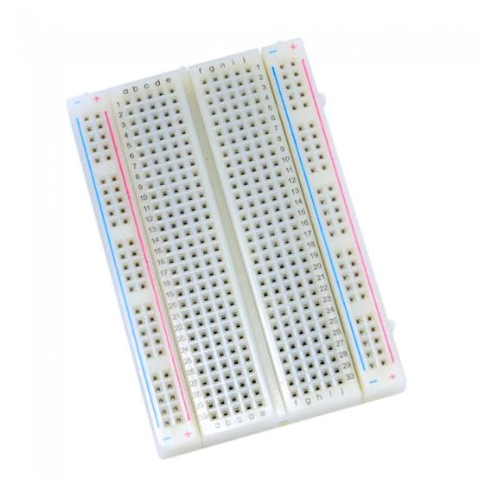

A breadboard is a rectangular plastic board with a bunch of tiny holes in it. These holes let you easily insert electronic components to prototype (meaning to build and test an early version of an electronic circuit, like this one with a battery, switch, resistor, and an LED (light-emitting diode).

The connections are not permanent, so it is easy to remove a component if you make a mistake, or just start over and do a new project. This makes breadboards great for beginners who are new to electronics. You can use breadboards to make all sorts of fun electronics projects, from different types of robots or an electronic drum set, to an electronic rain detector to help conserve water in a garden, just to name a few.

**MULTIMETER:**

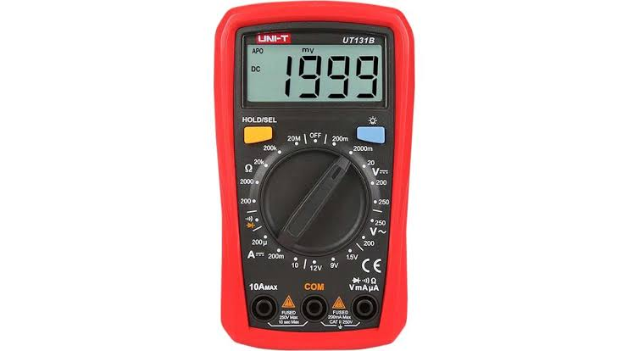

The most basic things we measure are voltage and current. A multimeter is also great for some basic sanity checks and troubleshooting. Is your circuit not working? Does the switch work? Put a meter on it! The multimeter is your first defense when troubleshooting a system. In this experiment we will cover measuring voltage, current, resistance and continuity.

Parts of a Multimeter

A multimeter is has three parts:

• Display

• Selection Knob

• Ports

The display usually has four digits and the ability to display a negative sign. A few multimeters

have illuminated displays for better viewing in low light situations.

The selection knob allows the user to set the multimeter to read different things such as

milliamps (mA) of current, voltage (V) and resistance (Ω).